**DATABASE SYSTEMS**

**BENGKEL KENDARAAN**



Dosen:

Desi Arisandi, S.Kom,M.T.I

Disusun Oleh:

1. Georgia Sugisandhea 535230080

2. Lusy Karlina Coa 535230164

3. Eryca Dhamma Shanty 535230071

4. Brenda Abigail Han’s 535230194

5. Brandon Alexander Jayadi 535230088

Kelas TI C – Kelompok 3

PRODI TEKNIK INFORMATIKA

**UNIVERSITAS TARUMANAGARA**

**JAKARTA**

**2023**DAFTAR ISI

PERANCANGAN KONSEPTUAL 3

Tahap 1.1 Menentukan Entitas 3

Tahap 1.2 Menentukan Relationship 4

Tahap 1.3 & 1.4 Menentukan Attribute dan domain 5

Tahap 1.5 Menentukan Primary Key dan Alternate Key 7

PERANCANGAN LOGICAL 7

Tahap 2.1 Logical Database Design 8

(2.1.1) Strong Entity: 8

(2.1.2) Weak Entity: 8

(2.1.3) 1:1 Binary Relationship Types 8

(2.1.4) 1:* Binary Relationship Types 8

(2.1.5) *:* Binary Relationship Types 8

Tahap 2.2 Normalisasi 10

Tahap 2.3 Validasi integritas menggunakan user transaction 12

Tahap 2.4 Integrity Constraints 13

PERANCANGAN FISIKAL 15

Query 21

LINK VIDEO YOUTUBE 33

# PERANCANGAN KONSEPTUAL

## Tahap 1.1 Menentukan Entitas

Entitas:

* Staff
* Customer
* Sales
* SparePart
* Vehicles
* Supplier

|  |  |  |  |
| --- | --- | --- | --- |
| Entity Name | Description | Aliases | Occurrence |
| Staff | Orang yang bertugas memperbaiki kendaraan | Employee / worker | Setiap staff memiliki tugas memperbaiki kendaraan yang dimasukkan oleh customer. Keterangan Staff tercatat kedalam tabel ini. |
| Customer | Orang yang menerima jasa perbaikan atau membeli barang | - | Setiap Customer |
| Sales | Orang yang menjual barang(sparepart) ke konsumen | - | Setiap Sales memiliki tugas untuk menjual suatu barang (Spare Part) kepada konsumen. Keterangan Sales tercatat kedalam tabel ini. |
| SparePart | Peralatan atau mesin kendaraan | - | Setiap produk (SparePart) |
| Vehicles | Kendaraan | - | Setiap kendaraan memiliki |
| Supplier | Orang atau pihak yang akan menyuplai barang(sparepart) ke bengkel | Provider | Supplier menyuplai barang(spare part) ke bengkel |

**New Entitas:**

* Customer make transaction Sales menghasilkan entitas baru Transaction.
* Vehicles fixed Staff menghasilkan entitas baru Service.
* SparePart provides Supplier menghasilkan entitas baru Inventory.

## Tahap 1.2 Menentukan Relationship

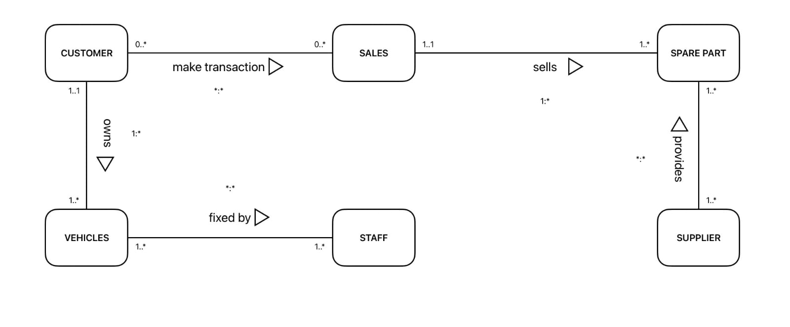

|  |  |  |  |  |
| --- | --- | --- | --- | --- |
| Entity | Multiplicity | Relationship | Multiplicity | Entity Name |
| Customer | 0…*  1…1 | Make transaction  Owns | 0…*  1…* | Sales  Vehicles |
| Sales | 1..1 | Sells | 1..* | Spare Part |
| Vehicles | 1...* | Fixed by | 1...* | Staff |
| Supplier | 1...* | Provides | 1...* | Spare Part |

Asumsi:

1. Customer bisa tidak melakukan transaksi sampai banyak melakukan transaksi ke sales dan sales bisa tidak dilakukan transaksi sampai banyak dilakukan transaksi oleh customer
2. Customer bisa memiliki satu sampai banyak vehicles sedangkan vehicles hanya bisa dimiliki satu customer
3. Sales bisa menjual satu sampai banyak spare part sedangkan spare part hanya bisa dijual oleh satu sales
4. Vehicles bisa diperbaiki oleh satu sampai banyak staff dan begitu sebaliknya. Staff bisa memperbaiki satu sampai banyak vehicles
5. Supplier bisa menyediakan satu sampai banyak spare part dan spare part bisa disediakan oleh satu sampai banyak supplier

## Tahap 1.3 & 1.4 Menentukan Attribute dan domain

Attribute for entities:

1. Staff: Staff_ID, Staff_Name(composite: fname, lname), Specialization, Telephone, Email, Address, Date_Of_Birth, Hire_Date, Gender, Salary.
2. Customer: Customer_ID,Name(composite: fname, lname), Telephone, Email, Address, Gender.
3. Sales: Sales_ID,Name( composite: fname, lname), Telephone, Email, Address, Date_Of_Birth, Hire_Date, Gender, Salary.
4. SparePart: Product_ID, Product_Name, Type, Brand.
5. Vehicles: Plate_Number, Vehicle_Name, Type.
6. Supplier: Supplier_ID, Supplier_Name, City, Street, Postcode.

|  |  |  |  |  |  |
| --- | --- | --- | --- | --- | --- |
| **Entity** | **Atribut** | **Deskripsi** | **Null** | **Multi Value** | **Domain** |
| Staff | Staff_ID  Staff_Name  fname  lname  Specialization  Telephone  Email  Address  Date_Of_Birth  Hire_Date  Gender  Salary | Staff ID  Nama Staff  Nama depan staff  Nama belakang staff  Keahlian staff  Nomor telepon staff  Email staff  Alamat staff  Tanggal lahir staff  Tanggal penerimaan  Jenis kelamin  Gaji staff | Yes  Yes  Yes  No  No  No  No  No  No  No  No | No  No  No  No  No  No  No  No  No  No  No | 5 Number  20 Variable Character  20 Variable Character(unique)  10 Variable Character  10 Number  20 Variable Character(unique)  20 Variable Character  Date  Date  1 Variable Character (F /M)  10 Number |
| Customer | Customer_ID  Customer_Name  fname  lname  Telephone  Email  Address  Gender | Customer ID  Nama customer  Nama depan customer  Nama belakang customer  Nomor telepon customer  Email customer  Alamat customer  Jenis kelamin | Yes  Yes  Yes  No  No  No  No | No  No  No  No  No  No  No | 5 Number  20 Variable Character  20 Variable Character(unique)  10 Number  20 Variabel Character(unique)  20 Variabel Character  1 Variable Character (F /M) |
| Sales | Sales_ID  Sales_Name  fname  lname  Telephone  Email  Address  Date_Of_Birth  Hire_Date  Gender  Salary | Sales ID  Nama sales  Nama depan sales  Nama belakang sales  Nomor telepon sales  Email sales  Alamat sales  Tanggal lahir sales  Tanggal penerimaan  Jenis kelamin  Gaji sales | Yes  Yes  Yes  No  No  No  No  No  No  No | No  No  No  No  No  No  No  No  No  No | 5 Number  20 Variable Character  20 Variable Character(unique)  10 Number  20 Variable Character(unique)  30 Variable Character  Date  Date  1 Variable Character (F /M)  10 Number |
| SparePart | Product_ID  Product_Name  Type  Brand | ID produk  Nama produk  Tipe produk  Merek produk | Yes  Yes  No  No | No  No  No  No | 5 Number  20 Variable Character  20 Variable Character  20 Variable Character |
| Vehicles | Plate_Number  Vehicle_Name  Type | Plat nomor  Varian kendaraan  Tipe kendaraan | Yes  Yes  No | No  No  No | 5 Number  20 Variable Character  20 Variable Character |
| Supplier | Supplier_ID  Supplier_Name  City  Street  Postcode | ID supplier  Nama supplier  Kota tempat supplier  Nama jalan  Kodepos | Yes  Yes  No  No  No | No  No  No  No  No | 5 Number  30 Variable Character  20 Variable Character  30 Variable Character  5 Number |

Attribute for Relationship:

1. Transaction: Purchase_ID, Product_ID, Customer_ID, Sales_ID, Purchase_DATE.
2. Inventory: Serial_Number,Product_ID,Supplier_ID, Stock, Price, Date_IN.
3. Service: Service_ID, Plate_Number, Staff_ID, Date_OUT, Notes, Price.

|  |  |  |  |  |  |
| --- | --- | --- | --- | --- | --- |
| Entity | Atribut | Deskripsi | Not Null | Multi Value | Domain |
| Transaction | Purchase_ID  Purchase_DATE | ID pembayaran  Tanggal pembayaran | No  No | No  No | 10 Number  Date |
| Inventory | Serial_Number  Stock  Price  Date_IN | Nomor seri barang  Jumlah barang  Harga barang  Tanggal masuk | No  No  No  No | No  No  No  No | 10 Number  4 Number  10 Number  Date |
| Service | Service_ID  Date_IN  Date_OUT  Notes  Price | ID servis  Tanggal masuk  Tanggal keluar  Catatan  Harga servis | No  Yes  No  No  No | No  No  No  No  No | 7 Number  Date  Date  75 Variable Character  9 Number |

## Tahap 1.5 Menentukan Primary Key dan Alternate Key

* Staff

Primary Key: Staff_ID

Alternate Key: Telephone

* Customer

Primary Key: Customer_ID

Alternate Key: Telephone

* Sales

Primary Key: Sales_ID

Alternate Key: Telephone

* Spare Part

Primary Key: Product_ID

Alternate Key: Product_Name

* Vehicles

Primary Key: Plate_number

Alternate Key: vehicle_name

* Supplier

Primary Key: Supplier_ID

Alternate Key: Supplier_Name, postcode

# PERANCANGAN LOGICAL

## Tahap 2.1 Logical Database Design

### (2.1.1) Strong Entity:

* Staff: Staff_ID(PK), Staff_Name(composite: fname, lname), Specialization, Telephone, Email, Address, Date_Of_Birth, Hire_Date, Gender, Salary.
* Customer: Customer_ID(PK), Customer_Name(composite: fname, lname), Telephone, Email, Address, Gender.
* Sales: Sales_ID(PK), Sales_Name(composite: fname,lname), Telephone, Email, Address, Date_Of_Birth, Hire_Date, Gender, Salary.
* Spare Part: Product_ID(PK), Product_Name, Type, Brand.
* Vehicles: Plate_Number(PK), Vehicle_Name, Type.
* Supplier Supplier_ID(PK), Supplier_Name, City, Street, Postcode.

### (2.1.2) Weak Entity:

* Tidak memiliki weak entity.

### (2.1.3) 1:1 Binary Relationship Types

* Tidak ada

### (2.1.4) 1:* Binary Relationship Types

* Customer(parent) owns Vehicles(child)
* Customer: Customer_ID(PK), Customer_Name(composite: fname, lname), Telephone, Email, Address, Gender.
* Vehicles: Plate_Number(PK), Vehicle_Name, Type, customer_ID(FK).
* Sales(parent) sells Spare Part(child)
* Sales: Sales_ID(PK), Sales_Name(composite: fname, lname), Telephone, Email, Address, Date_Of_Birth, Hire_Date, Gender, Salary.
* SparePart: Product_ID(PK), Product_Name, Type, Brand, Sales_ID(FK).

### (2.1.5) *:* Binary Relationship Types

* Staff fixed Vehicles
* Staff: Staff_ID(PK), Staff_Name(composite: fname, lname), Specialization, Telephone, Email, Address, Date_Of_Birth, Hire_Date, Gender, Salary.
* Vehicles: Plate_Number(PK), Vehicle_Name, Type, customer_ID(FK).
* Service: Service_ID(PK), Plate_Number(FK), Staff_ID(FK), Date_IN, Date_OUT, Notes, Price
* Customer make transaction to Sales
* Sales: Sales_ID(PK), Sales_Name(composite: fname, lname), Telephone, Email, Address, Date_Of_Birth, Hire_Date, Gender, Salary.
* Customer: Customer_ID(PK), Customer_Name(composite: fname, lname), Telephone, Email, Address, Gender.
* Transaction: Purchase_ID(PK), Product_ID(FK), Customer_ID(FK), Sales_ID(FK), Purchase_Date.
* Supplier provides Spare Part
* Supplier Supplier_ID(PK), Supplier_Name, City, Street, Postcode.
* SparePart: Product_ID(PK), Product_Name, Type, Brand, Sales_ID(FK).
* Inventory: Serial_Number(PK), Product_ID(FK), Supplier_ID(FK), Stock, Price, Date_IN.

Table-table yang terbentuk:

1. Staff: Staff_ID(PK), Staff_Name(composite: fname, lname), Specialization, Telephone, Email, Address, Date_Of_Birth, Hire_Date, Gender, Salary.
2. Sales: Sales_ID(PK), Sales_Name(composite: fname, lname), Telephone, Email, Address, Date_Of_Birth, Hire_Date, Gender, Salary.
3. Customer: Customer_ID(PK), Customer_Name(composite: fname, lname), Telephone, Email, Address, Gender.
4. Transaction: Purchase_ID(PK), Product_ID(FK), Customer_ID(FK), Sales_ID(FK), Purchase_Date.
5. Vehicles: Plate_Number(PK), Vehicle_Name, Type, customer_ID(FK).
6. Supplier: Supplier_ID(PK), Supplier_Name, City, Street, Postcode.
7. SparePart: Product_ID(PK), Product_Name, Type, Brand, Sales_ID(FK).
8. Inventory: Serial_Number(PK), Product_ID(FK), Supplier_ID(FK), Stock, Price, Date_IN.
9. Service: Service_ID(PK), Plate_Number(FK), Staff_ID(FK), Date_IN, Date_OUT, Notes, Price.

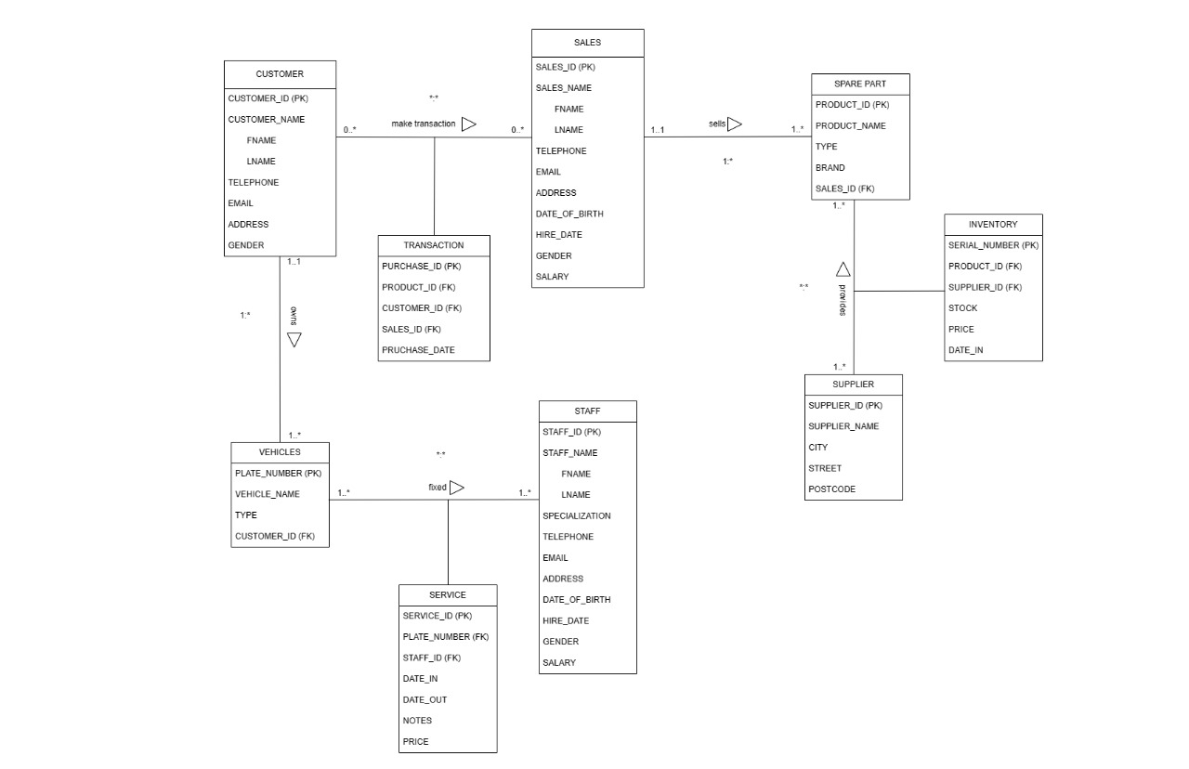

## Tahap 2.2 Normalisasi

Normalisasi tahap 1NF akan terjadi pada tabel Staff, Customer, dan Sales.

1NF:

* Tidak ada multivalued attribute
* Menghilangkan composite key
* Staff: Attribute Staff_Name berisi fname dan lname, di hilangkan composite key menjadi fname, lname.
* Sales: Attribute Sales_Name berisi fname dan lname, dihilangkan composite key menjadi fname, lname.
* Customer: Attribute Customer_Name, berisi fname dan lname, dihilangkan composite key menjadi fname, lname.
* Atribut dalam tabel bersifat atomic
* Pendefinisian primary key:
* Staff = Staff_ID
* Customer = Customer_ID
* Sales = Sales_ID
* SparePart = Product_ID
* Vehicles = Plate_Number
* Supplier = Supplier_ID

2NF:

* Sudah memenuhi normalisasi 2NF
* Tidak ada partial dependency
* Normalisasi tahap 2 sudah terpenuhi karena dalam diskusi awal kelompok kami, kami fokus kepada objek yang perlu ada di bengkel daripada report dan tabel yang perlu di normalisasi.

3NF:

* Sudah memenuhi normalisasi 3NF
* Tidak ada ketergantungan transitive

Hasil tabel yang terbentuk:

1. Staff: Staff_ID(PK), fname, lname, Specialization, Telephone, Email, Address, Date_Of_Birth, Hire_Date, Gender, Salary.
2. Sales: Sales_ID(PK), fname, lname, Telephone, Email, Address, Date_Of_Birth, Hire_Date, Gender, Salary.
3. Customer: Customer_ID(PK), fname, lname, Telephone, Email, Address, Gender.
4. Transaction: Purchase_ID(PK), Product_ID(FK), Customer_ID(FK), Sales_ID(FK), Purchase_Date.
5. Vehicles: Plate_Number(PK), Vehicle_Name, Type, customer_ID(FK).
6. Supplier: Supplier_ID(PK), Supplier_Name, City, Street, Postcode.
7. SparePart: Product_ID(PK), Product_Name, Type, Brand, Sales_ID(FK).
8. Inventory: Serial_Number(PK), Product_ID(FK), Supplier_ID(FK), Stock, Price, Date_IN.
9. Service: Service_ID(PK), Plate_Number(FK), Staff_ID(FK), Date_IN, Date_OUT, Notes, Price.

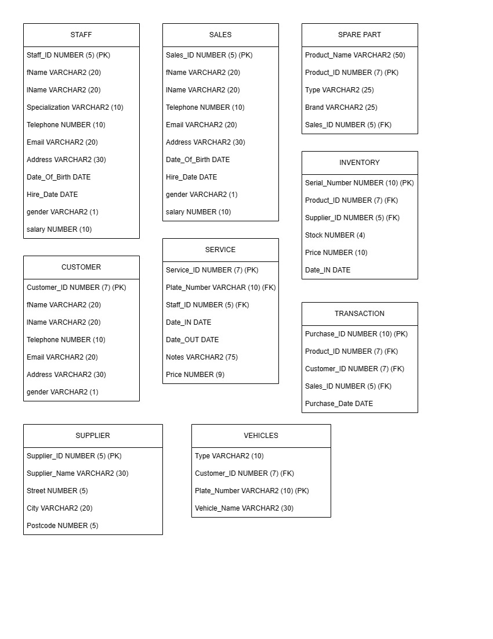

## Tahap 2.3 Validasi integritas menggunakan user transaction

Melalui ERD(Entity Relationship Diagram) yang ditampilkan dalam makalah kami, dipastikan bahwa *relations* antar tabel data yang dihubungkan dengan primary key dan foreign key, memenuhi untuk transaksi user. Sehingga transaksi yang perlu dilakukan oleh user bisa terpenuhi:

* Billing transaksi sparepart dengan data lengkap akan transaksi yang dilaksanakan, dibuat dengan join antara tabel customer, sales, transaction, dan sparepart.
* Billing service lengkap dengan catatan staff dan nama staff, dibuat melalui join antara staff vehicle dan juga customer.
* Laporan penjualan atau service sales dan staff dibuat dengan join antara sales dengan customer beserta sparepart, atau staff dengan vehicle, untuk melihat berapa penjualan/service yang mereka laksanakan dengan group function count. Yang kemudian bisa dipakai untuk menghitung komisi tiap pekerja menggunakan perkalian.
* Data laporan supplier yang berisi produk yang diambil dari supplier tersebut, beserta maksimum, minimum, dan rata rata harga digunakan untuk laporan dan pertimbangan kerja sama, menggunakan join antara inventory dan supplier, dan functions seperti max, min, avg, count, dan to_char.

## Tahap 2.4 Integrity Constraints

Berikut tercantum constraint yang ada di dalam masing masing tabel yang terbentuk:

1. Supplier

* Supplier_ID = primary key
* Supplier_Name = not null

1. Sales

* Sales_ID = primary key
* fname = not null
* lname = not null
* gender = check dengan pilihan value F atau M
* email, fname = unique composite

1. SparePart

* Product_ID = primary key
* Product_Name = not null
* Sales_ID = foreign key dari tabel Sales

1. Customer

* Customer_ID = primary key
* gender = check dengan pilihan value F atau M
* email, fname = unique composite

1. Vehicles

* Plate_Number = primary key
* Vehicle_Name = not null
* Type = not null
* Customer_ID = foreign key dari tabel Customer

1. Staff

* Staff_ID = primary key
* fname = not null
* lname = not null
* gender = check dengan pilihan value F atau M
* email, fname = unique composite

1. Inventory

* Serial_Number = primary key
* Supplier_ID = foreign key dari tabel Supplier
* Product_ID = foreign key dari tabel SparePart

1. Transaction

* Purchase_ID = primary key
* Product_ID = foreign key dari tabel SparePart
* Customer_ID = foreign key dari tabel Customer
* Sales_ID = foreign key dari tabel Sales

1. Service

* Service_ID = primary key
* Date_IN = not null
* Plate_Number = foreign key dari tabel Vehicles
* Staff_ID = foreign key dari tabel Staff

# PERANCANGAN FISIKAL

* Supplier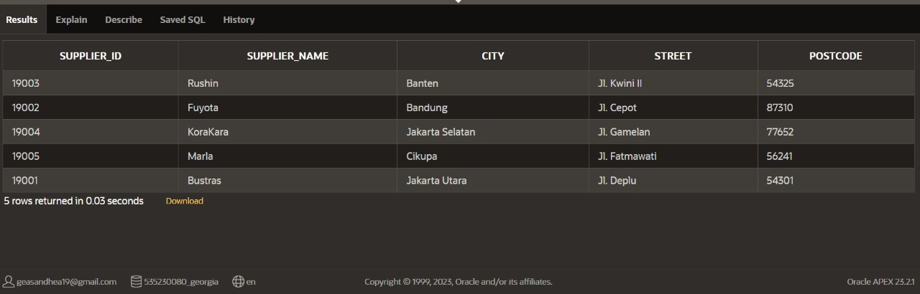
* Sales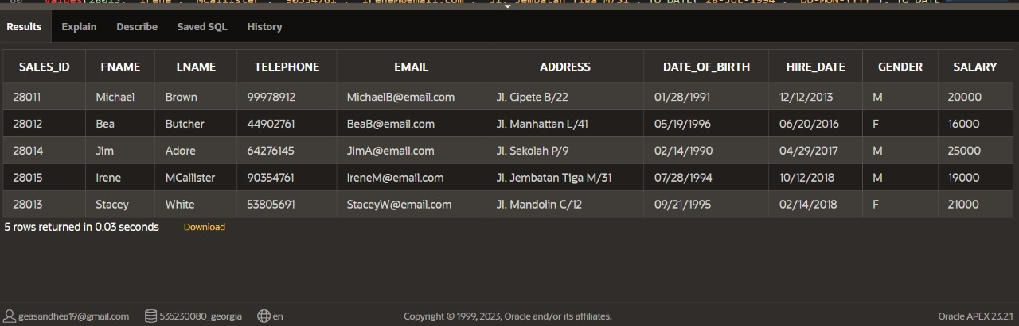
* SparePart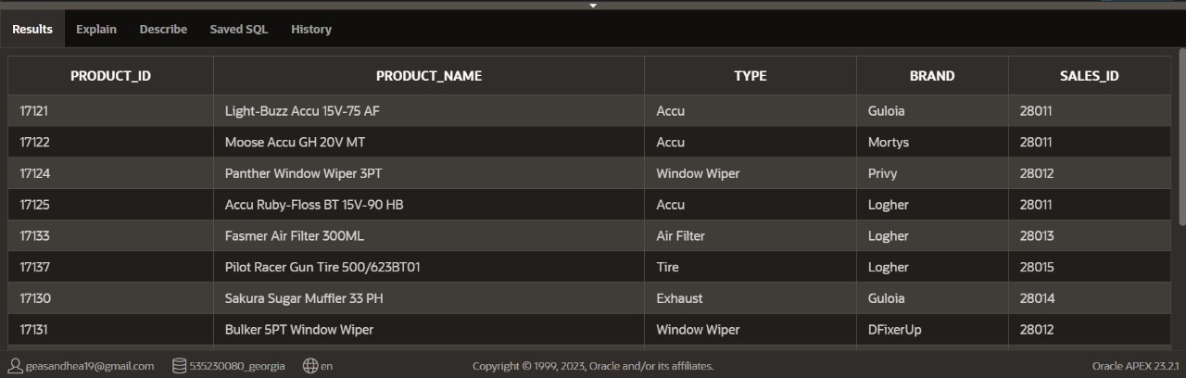

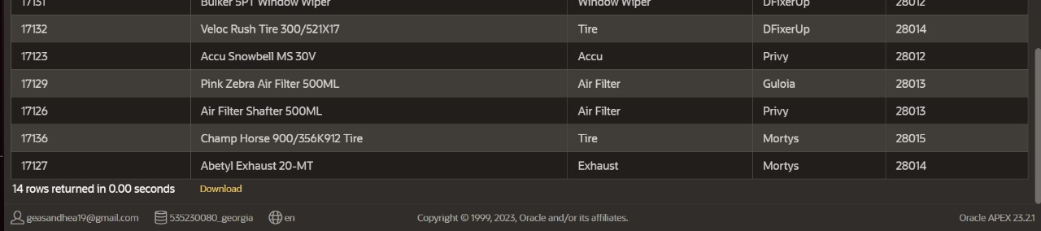

* Customer

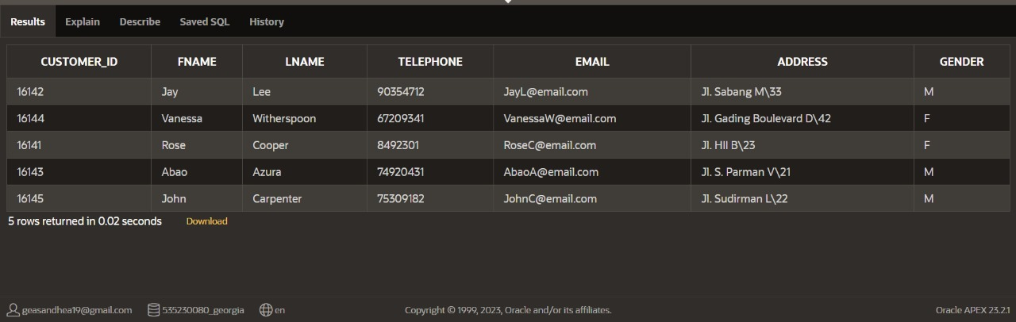

* Vehicles

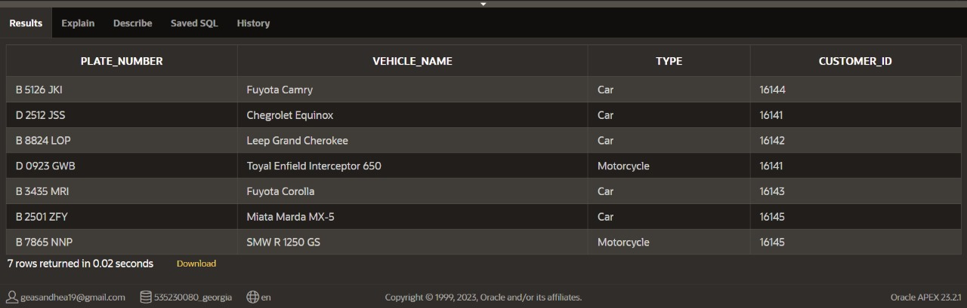

* Staff

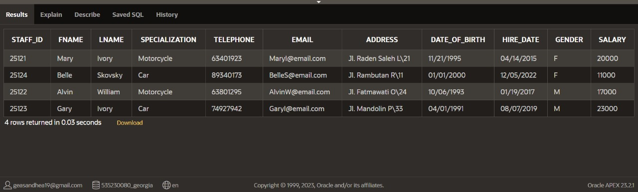

* Inventory

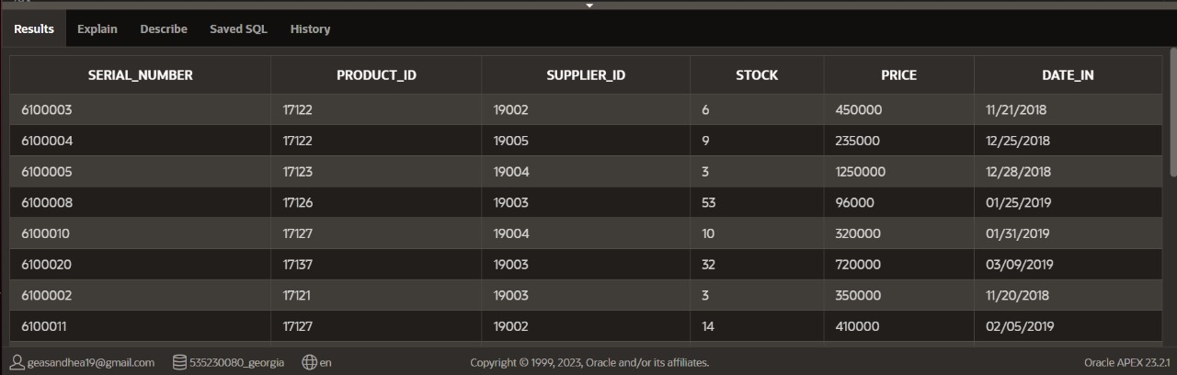

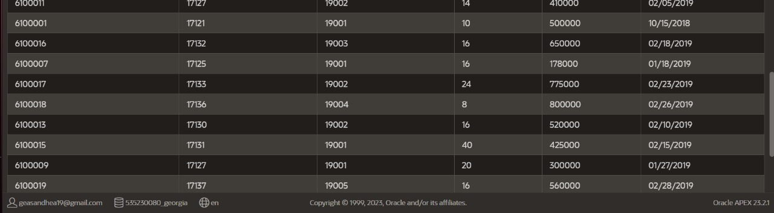

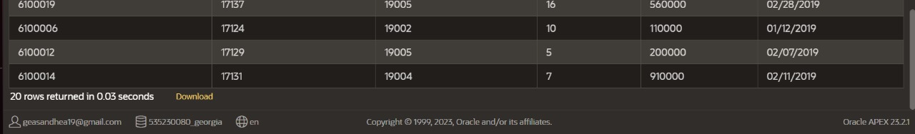

* Transaction

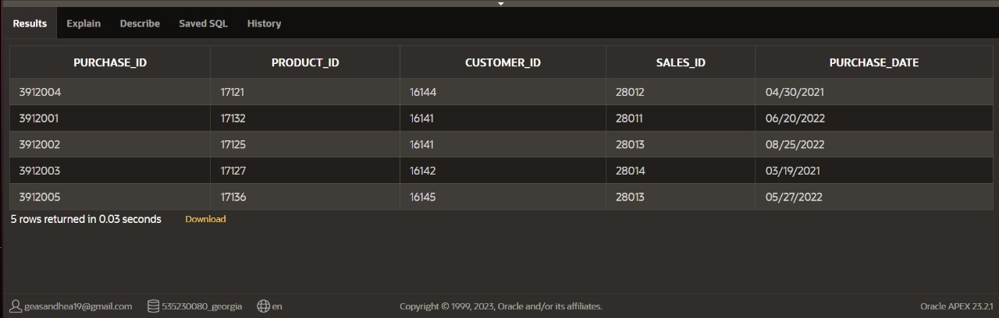

* Service

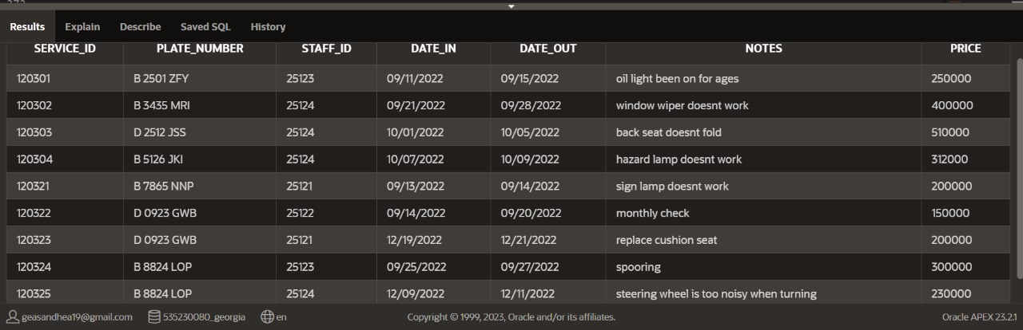

* Katalog service

Katalog service yang dilakukan oleh per staff, dimana staff nya diinput oleh user saat dijalankan. Menggunakan join, subquery, dan bind variable1

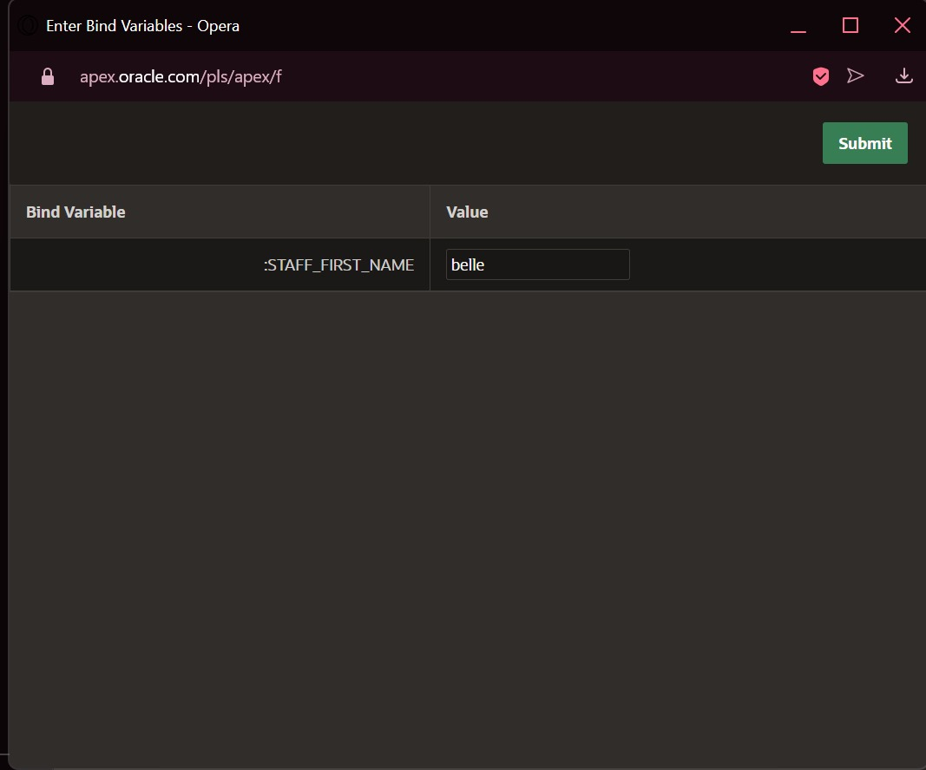

* Katalog service yang dilakukan oleh per staff, dimana staff nya diinput oleh user saat dijalankan. Menggunakan join, subquery, dan bind variable2

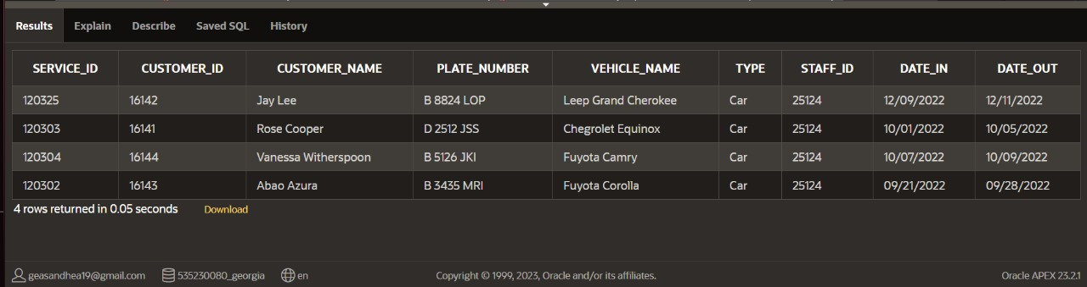

* Sebuah view berisi laporan minimum harga, maksimum harga, rata-rata harga, dan jumlah barang yang dibeli dari supplier tersebut. Menggunakan join, function, dan view.

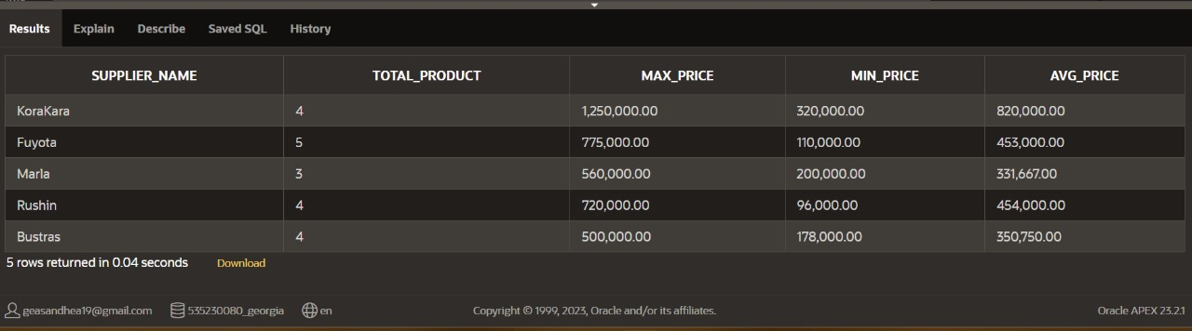

* Sebuah view sales_commission untuk melihat total penjualan sales dan menghitung komisi sesuai penjualan sales tersebut. Menggunakan conditional expressions, join, function, dan view.
* Sequence tidak dapat dipakai khusus dalam view, maka sequence kami gunakan di dalam create table.

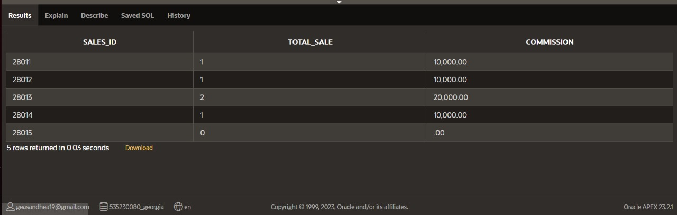

## Query

--tabel supplier = untuk menyimpan data data perusahaan supplier spareparts, seperti nama, dan lokasi dari supplier tersebut

--membuat tabel supplier beserta attribute dan constraintnya

create table supplier(

supplier_id number(5) constraint sup_pk primary key,

supplier_name varchar2(30) constraint sup_name_nn not null,

city varchar2(20),

street varchar2(30),

postcode number(5)

);

--memasukkan data ke tabel supplier

insert into supplier

values(19001, 'Bustras', 'Jakarta Utara', 'Jl. Deplu', 54301);

insert into supplier

values(19002, 'Fuyota', 'Bandung', 'Jl. Cepot', 87310);

insert into supplier

values(19003, 'Rushin', 'Banten', 'Jl. Kwini II', 54325);

insert into supplier

values(19004, 'KoraKara', 'Jakarta Selatan', 'Jl. Gamelan', 77652);

insert into supplier

values(19005, 'Marla', 'Cikupa', 'Jl. Fatmawati', 56241);

--menampilkan hasil tabel supplier

select *

from supplier;

--table sales = untuk menyimpan data lengkap orang orang yang bekerja di bengkel ini sebagai sales, seperti data biodata, kebutuhan kontak, dan gaji. constraint unique composite email dan nama pertama sebagai asumsi bisa ada orang berbeda memiliki email yang sama.

--membuat tabel sales beserta attribute dan constraintnya

create table sales(

sales_id number(5) constraint sls_pk primary key,

fname varchar2(20) constraint fname_nn not null,

lname varchar2(20) constraint lname_nn not null,

telephone number(10),

email varchar2(20),

address varchar2(30),

date_of_birth date,

hire_date date,

gender varchar2(1),

salary number(10),

constraint gen_ch check (gender IN('F', 'M')),

constraint sl_email_uq unique (email, fname)

);

--memasukkan data ke tabel sales

insert into sales

values(28011, 'Michael', 'Brown', '99978912', 'MichaelB@email.com', 'Jl. Cipete B/22', TO_DATE('28-JAN-1991', 'DD-MON-YYYY'), TO_DATE('12-DEC-2013', 'DD-MON-YYYY'), 'M', 20000);

insert into sales

values(28012, 'Bea', 'Butcher', '44902761', 'BeaB@email.com', 'Jl. Manhattan L/41', TO_DATE('19-MAY-1996', 'DD-MON-YYYY'), TO_DATE('20-JUN-2016', 'DD-MON-YYYY'), 'F', 16000);

insert into sales

values(28013, 'Stacey', 'White', '53805691', 'StaceyW@email.com', 'Jl. Mandolin C/12', TO_DATE('21-SEP-1995', 'DD-MON-YYYY'), TO_DATE('14-FEB-2018', 'DD-MON-YYYY'), 'F', 21000);

insert into sales

values(28014, 'Jim', 'Adore', '64276145', 'JimA@email.com', 'Jl. Sekolah P/9', TO_DATE('14-FEB-1990', 'DD-MON-YYYY'), TO_DATE('29-APR-2017', 'DD-MON-YYYY'), 'M', 25000);

insert into sales

values(28015, 'Irene', 'MCallister', '90354761', 'IreneM@email.com', 'Jl. Jembatan Tiga M/31', TO_DATE('28-JUL-1994', 'DD-MON-YYYY'), TO_DATE('12-OCT-2018', 'DD-MON-YYYY'), 'M', 19000);

--menampilkan hasil tabel sales

select *

from sales;

--table sparepart = untuk menyimpan data sparepart yang tersedia (dan pernah tersedia, karena sebagai catatan history transaksi di tabel transaction), beserta dengan sales yang bertanggung jawab dalam menjual produk tersebut.

--membuat tabel sparepart beserta attribute dan constraintnya

create table sparepart(

product_id number(7) constraint sp_pk primary key,

product_name varchar2(50) constraint sp_nn not null,

type varchar2(25),

brand varchar2(25),

sales_id number(5),

constraint sl_sp_fk foreign key(sales_id) references sales(sales_id) on delete set null

);

--memasukkan data ke tabel sparepart

insert into sparepart

values(17121, 'Light-Buzz Accu 15V-75 AF', 'Accu', 'Guloia', '28011');

insert into sparepart

values(17122, 'Moose Accu GH 20V MT', 'Accu', 'Mortys', '28011');

insert into sparepart

values(17125, 'Accu Ruby-Floss BT 15V-90 HB', 'Accu', 'Logher', '28011');

insert into sparepart

values(17123, 'Accu Snowbell MS 30V', 'Accu', 'Privy', '28012');

insert into sparepart

values(17124, 'Panther Window Wiper 3PT', 'Window Wiper', 'Privy', '28012');

insert into sparepart

values(17131, 'Bulker 5PT Window Wiper', 'Window Wiper', 'DFixerUp', '28012');

insert into sparepart

values(17126, 'Air Filter Shafter 500ML', 'Air Filter', 'Privy', '28013');

insert into sparepart

values(17129, 'Pink Zebra Air Filter 500ML', 'Air Filter', 'Guloia', '28013');

insert into sparepart

values(17133, 'Fasmer Air Filter 300ML', 'Air Filter', 'Logher', '28013');

insert into sparepart

values(17127, 'Abetyl Exhaust 20-MT', 'Exhaust', 'Mortys', '28014');

insert into sparepart

values(17130, 'Sakura Sugar Muffler 33 PH', 'Exhaust', 'Guloia', '28014');

insert into sparepart

values(17132, 'Veloc Rush Tire 300/521X17', 'Tire', 'DFixerUp', '28014');

insert into sparepart

values(17137, 'Pilot Racer Gun Tire 500/623BT01', 'Tire', 'Logher', '28015');

insert into sparepart

values(17136, 'Champ Horse 900/356K912 Tire', 'Tire', 'Mortys', '28015');

--menampilkan hasil tabel sparepart

select *

from sparepart;

--tabel customer= menyimpan data customer yang pernah bertransaksi/melakukan servis di bengkel ini, seperti nama beserta gender, dan kebutuhan kontak serta alamat, constraint unique composite email dan nama pertama sebagai asumsi bisa ada orang berbeda memiliki email yang sama.

--membuat tabel customer beserta attribute dan constraintnya

create table customer(

customer_id number(7) constraint cus_pk primary key,

fname varchar2(20),

lname varchar2(20),

telephone number(10),

email varchar2(20),

address varchar2(30),

gender varchar2(1),

constraint cus_gen_ch check (gender IN('F', 'M')),

constraint cus_email_uq unique (email,fname)

);

--memasukkan data ke tabel customer

insert into customer

values(16141, 'Rose', 'Cooper', '08492301', 'RoseC@email.com', 'Jl. HII B\23', 'F');

insert into customer

values(16142, 'Jay', 'Lee', '90354712', 'JayL@email.com', 'Jl. Sabang M\33', 'M');

insert into customer

values(16143, 'Abao', 'Azura', '74920431', 'AbaoA@email.com', 'Jl. S. Parman V\21', 'M');

insert into customer

values(16144, 'Vanessa', 'Witherspoon', '67209341', 'VanessaW@email.com', 'Jl. Gading Boulevard D\42', 'F');

insert into customer

values(16145, 'John', 'Carpenter', '75309182', 'JohnC@email.com', 'Jl. Sudirman L\22', 'M');

--menampilkan hasil tabel customer

select *

from customer;

--table vehicles = untuk menyimpan data lengkap kendaraan yang pernah melakukan servis di bengkel ini, beserta dengan id pemiliknya

--membuat tabel vehicles beserta attribute dan constraintnya

create table vehicles(

plate_number varchar2(10) constraint vh_pl_pk primary key,

vehicle_name varchar2(30) constraint vh_nm_nn not null,

type varchar2(10) constraint vh_ty_nn not null,

customer_id number(7),

constraint vh_id_fk foreign key(customer_id) references customer(customer_id) on delete cascade

)

--memasukkan data ke tabel vehicles

insert into vehicles

values('B 5126 JKI', 'Fuyota Camry', 'Car', '16144');

insert into vehicles

values('D 2512 JSS', 'Chegrolet Equinox', 'Car', '16141');

insert into vehicles

values('B 8824 LOP', 'Leep Grand Cherokee', 'Car', '16142');

insert into vehicles

values('B 3435 MRI', 'Fuyota Corolla', 'Car', '16143');

insert into vehicles

values('D 0923 GWB', 'Toyal Enfield Interceptor 650', 'Motorcycle', '16141');

insert into vehicles

values('B 7865 NNP', 'SMW R 1250 GS', 'Motorcycle', '16145');

insert into vehicles

values('B 2501 ZFY', 'Miata Marda MX-5', 'Car', '16145');

--menampilkan hasil tabel vehicles

select *

from vehicles;

--table staff = untuk menyimpan data orang orang yang bekerja di bengkel ini sebagai staff montir, seperti data biodata, kebutuhan kontak, dan gaji. constraint unique composite email dan nama pertama sebagai asumsi bisa ada orang berbeda memiliki email yang sama.

--membuat tabel staff beserta attribute dan constraintnya

create table staff(

staff_id number(5) constraint stf_pk primary key,

fname varchar2(20) constraint stf_fname_nn not null,

lname varchar2(20) constraint stf_lname_nn not null,

specialization varchar2(10),

telephone number(10),

email varchar2(20),

address varchar2(30),

date_of_birth date,

hire_date date,

gender varchar2(1),

salary number(10),

constraint stf_gen_ch check (gender IN('F', 'M')),

constraint stf_email_uq unique (email, fname)

);

--memasukkan data ke tabel staff

insert into staff

values(25121, 'Mary', 'Ivory', 'Motorcycle', '63401923', 'MaryI@email.com', 'Jl. Raden Saleh L\21', TO_DATE('21-NOV-1995', 'DD-MON-YYYY'), TO_DATE('14-APR-2015', 'DD-MON-YYYY'), 'F', '20000');

insert into staff

values(25122, 'Alvin', 'William', 'Motorcycle', '63801295', 'AlvinW@email.com', 'Jl. Fatmawati O\24', TO_DATE('06-OCT-1993', 'DD-MON-YYYY'), TO_DATE('19-JAN-2017', 'DD-MON-YYYY'), 'M', '17000');

insert into staff

values(25123, 'Gary', 'Ivory', 'Car', '74927942', 'GaryI@email.com', 'Jl. Mandolin P\33', TO_DATE('01-APR-1991', 'DD-MON-YYYY'), TO_DATE('07-AUG-2019', 'DD-MON-YYYY'), 'M', 23000);

insert into staff

values(25124, 'Belle', 'Skovsky', 'Car', '89340173', 'BelleS@email.com', 'Jl. Rambutan R\11', TO_DATE('01-JAN-2000', 'DD-MON-YYYY'), TO_DATE('05-DEC-2022', 'DD-MON-YYYY'), 'F', 11000);

--menampilkan hasil tabel staff

select *

from staff;

--table inventory; new entity hasil many to many relationship antara supplier dan sparepart. Menyimpan data masing masing sparepart beserta dengan supplier yang menyediakan produk tersebut, dan harga yang dijual oleh suppliernya. Asumsi bahwa jenis sparepart yang sama bisa dijual oleh supplier yang berbeda.

--membuat tabel inventory beserta attribute dan constraintnya

create table inventory(

serial_number number(10) constraint inv_pk primary key,

product_id number(7),

supplier_id number(5),

stock number(4),

price number(10),

date_in date,

constraint inv_sup_fk foreign key(supplier_id) references supplier(supplier_id) on delete cascade,

constraint inv_pr_fk foreign key(product_id) references sparepart(product_id)

);

--memasukkan data ke tabel inventory

insert into inventory

values(06100001, 17121, 19001, 10, 500000, TO_DATE('15-OCT-2018', 'DD-MON-YYYY'));

insert into inventory

values(06100002, 17121, 19003, 3, 350000, TO_DATE('20-NOV-2018', 'DD-MON-YYYY'));

insert into inventory

values(06100003, 17122, 19002, 6, 450000, TO_DATE('21-NOV-2018', 'DD-MON-YYYY'));

insert into inventory

values(06100004, 17122, 19005, 9, 235000, TO_DATE('25-DEC-2018', 'DD-MON-YYYY'));

insert into inventory

values(06100005, 17123, 19004, 3, 1250000, TO_DATE('28-DEC-2018', 'DD-MON-YYYY'));

insert into inventory

values(06100006, 17124, 19002, 10, 110000, TO_DATE('12-JAN-2019', 'DD-MON-YYYY'));

insert into inventory

values(06100007, 17125, 19001, 16, 178000, TO_DATE('18-JAN-2019', 'DD-MON-YYYY'));

insert into inventory

values(06100008, 17126, 19003, 53, 96000, TO_DATE('25-JAN-2019', 'DD-MON-YYYY'));

insert into inventory

values(06100009, 17127, 19001, 20, 300000, TO_DATE('27-JAN-2019', 'DD-MON-YYYY'));

insert into inventory

values(06100010, 17127, 19004, 10, 320000, TO_DATE('31-JAN-2019', 'DD-MON-YYYY'));

insert into inventory

values(06100011, 17127, 19002, 14, 410000, TO_DATE('05-FEB-2019', 'DD-MON-YYYY'));

insert into inventory

values(06100012, 17129, 19005, 5, 200000, TO_DATE('07-FEB-2019', 'DD-MON-YYYY'));

insert into inventory

values(06100013, 17130, 19002, 16, 520000, TO_DATE('10-FEB-2019', 'DD-MON-YYYY'));

insert into inventory

values(06100014, 17131, 19004, 7, 910000, TO_DATE('11-FEB-2019', 'DD-MON-YYYY'));

insert into inventory

values(06100015, 17131, 19001, 40, 425000, TO_DATE('15-FEB-2019', 'DD-MON-YYYY'));

insert into inventory

values(06100016, 17132, 19003, 16, 650000, TO_DATE('18-FEB-2019', 'DD-MON-YYYY'));

insert into inventory

values(06100017, 17133, 19002, 24, 775000, TO_DATE('23-FEB-2019', 'DD-MON-YYYY'));

insert into inventory

values(06100018, 17136, 19004, 8, 800000, TO_DATE('26-FEB-2019', 'DD-MON-YYYY'));

insert into inventory

values(06100019, 17137, 19005, 16, 560000, TO_DATE('28-FEB-2019', 'DD-MON-YYYY'));

insert into inventory

values(06100020, 17137, 19003, 32, 720000, TO_DATE('09-MAR-2019', 'DD-MON-YYYY'));

--menampilkan hasil tabel inventory

select *

from inventory;

--table transaction; new entity hasil many to many relationship antara sales dan customer. Untuk menyimpan history data transaksi sparepart oleh customer yang dijual oleh sales, untuk kemudahan dalam membuat laporan dan kebutuhan garansi.

--membuat tabel transaction beserta attribute dan constraintnya

create table transaction(

purchase_id number(10) constraint trns_pk primary key,

product_id number(7),

customer_id number(7),

sales_id number(5),

purchase_date date,

constraint trns_pr_fk foreign key(product_id) references sparepart(product_id),

constraint trns_cus_fk foreign key(customer_id) references customer(customer_id),

constraint trns_sl_fk foreign key(sales_id) references sales(sales_id)

);

--memasukkan data ke tabel transaction

insert into transaction

values(3912001, 17132, 16141, 28011, TO_DATE('20-JUN-2022', 'DD-MON-YYYY'));

insert into transaction

values(3912002, 17125, 16141, 28013, TO_DATE('25-AUG-2022', 'DD-MON-YYYY'));

insert into transaction

values(3912003, 17127, 16142, 28014, TO_DATE('19-MAR-2021', 'DD-MON-YYYY'));

insert into transaction

values(3912004, 17121, 16144, 28012, TO_DATE('30-APR-2021', 'DD-MON-YYYY'));

insert into transaction

values(3912005, 17136, 16145, 28013, TO_DATE('27-MAY-2022', 'DD-MON-YYYY'));

--menampilkan hasil tabel transaction

select *

from transaction;

--table service; new entity hasil many to many relationship antara staff dan vehicle. Untuk menyimpan data history service kendaraan oleh staff montir, untuk kebutuhan laporan staff dan rekam servis masing masing kendaraan

--membuat tabel service beserta attribute dan constraintnya

create table service(

service_id number(7) constraint ser_pk primary key,

plate_number varchar(10),

staff_id number(5),

date_in date constraint ser_dtin_nn not null,

date_out date,

notes varchar2(75),

price number(9),

constraint ser_vh_fk foreign key(plate_number) references vehicles(plate_number),

constraint ser_st_fk foreign key(staff_id) references staff(staff_id)

);

--membuat sequence untuk membuat angka berurutan di atribut service id dalam tabel service

create sequence srv_seq

start with 120301

increment by 1;

--memasukkan data ke tabel service

insert into service

values(srv_seq.nextval, 'B 2501 ZFY', 25123, TO_DATE('11-SEP-2022', 'DD-MON-YYYY'), TO_DATE('15-SEP-2022', 'DD-MON-YYYY'), 'oil light been on for ages', 250000);

insert into service

values(srv_seq.nextval, 'B 7865 NNP', 25121, TO_DATE('13-SEP-2022', 'DD-MON-YYYY'), TO_DATE('14-SEP-2022', 'DD-MON-YYYY'), 'sign lamp doesnt work', 200000);

insert into service

values(srv_seq.nextval, 'D 0923 GWB', 25122, TO_DATE('14-SEP-2022', 'DD-MON-YYYY'), TO_DATE('20-SEP-2022', 'DD-MON-YYYY'), 'monthly check', 150000);

insert into service

values(srv_seq.nextval, 'B 3435 MRI', 25124, TO_DATE('21-SEP-2022', 'DD-MON-YYYY'), TO_DATE('28-SEP-2022', 'DD-MON-YYYY'), 'window wiper doesnt work', 400000);

insert into service

values(srv_seq.nextval, 'D 0923 GWB', 25121, TO_DATE('19-DEC-2022', 'DD-MON-YYYY'), TO_DATE('21-DEC-2022', 'DD-MON-YYYY'), 'replace cushion seat', 200000);

insert into service

values(srv_seq.nextval, 'B 8824 LOP', 25123, TO_DATE('25-SEP-2022', 'DD-MON-YYYY'), TO_DATE('27-SEP-2022', 'DD-MON-YYYY'), 'spooring', 300000);

insert into service

values(srv_seq.nextval, 'D 2512 JSS', 25124, TO_DATE('01-OCT-2022', 'DD-MON-YYYY'), TO_DATE('05-OCT-2022', 'DD-MON-YYYY'), 'back seat doesnt fold', 510000);

insert into service

values(srv_seq.nextval, 'B 5126 JKI', 25124, TO_DATE('07-OCT-2022', 'DD-MON-YYYY'), TO_DATE('09-OCT-2022', 'DD-MON-YYYY'), 'hazard lamp doesnt work', 312000);

insert into service

values(srv_seq.nextval, 'B 8824 LOP', 25124, TO_DATE('09-DEC-2022', 'DD-MON-YYYY'), TO_DATE('11-DEC-2022', 'DD-MON-YYYY'), 'steering wheel is too noisy when turning', 230000);

--menampilkan hasil tabel service dengan tambahan order by

select *

from service

order by service_id;

--katalog service yang dilakukan oleh per staff, dimana staffnya diinput oleh user saat dijalankan. Menggunakan join, subquery, dan bind variable. Berikut querynya

select s.service_id, c.customer_id, c.fname||' '||c.lname as customer_name, v.plate_number, v.vehicle_name, v.type, s.staff_id, s.date_in, s.date_out

from customer c join vehicles v on(c.customer_id = v.customer_id) join service s on(v.plate_number = s.plate_number)

where s.staff_id=(

select staff_id

from staff

where upper(fname)= upper(:staff_first_name)

);

--sebuah view berisi laporan minimum harga, maksimum harga, rata-rata harga, dan jumlah barang yang dibeli dari supplier tersebut. Menggunakan join, function, dan view.

--membuat view supplier_report

create view supplier_report as select supplier_name, count(product_id) as total_product, to_char(max(price), '9,999,999.99') as max_price, to_char(min(price), '9,999,999.99') as min_price, to_char(round(avg(price)), '9,999,999.99') as avg_price

from inventory natural join supplier

group by supplier_name;

--menampilkan view supplier_report

select * from supplier_report;

--sebuah view sales_commission untuk melihat total penjualan sales dan menghitung komisi sesuai penjualan sales tersebut. Menggunakan conditional expressions, join, function, dan view.

--membuat view sales_commission

create view sales_commission as select s.sales_id, nvl(count(purchase_id), 0) as total_sale, to_char((nvl(count(purchase_id), 0)*10000), '999,999.99') as commission

from sales s left outer join transaction t on(s.sales_id = t.sales_id)

group by s.sales_id

order by s.sales_id;

--menampilkan view sales_commission

select * from sales_commission;

--sequence tidak dapat dipakai khusus dalam view, maka sequence kami gunakan di dalam create table.

## LINK VIDEO YOUTUBE

<https://youtu.be/BrKhJmvL5_I?si=3Q83lO51ATlrFyQ6>